
Mehran University of Engineering and Technology Jamshoro

ASSIGNMENT : Design Procedure of Modern Regulated Power Supply
SUBJECT : APPLIED PHYSICS
ROLL NO : 24BSAI29
SUBMITTED BY : SYED MUHAMMAD QASIM
SUBMITTED TO : DR. ABDUL HAKIM MEMON

Introduction:
Modern regulated power supplies are indispensable in electronic systems, providing consistent and reliable power delivery to sensitive components. These devices are designed to maintain a stable output voltage or current despite fluctuations in input voltage or varying load demands. Their applications range from small household electronics to large-scale industrial machinery, making their design and efficiency critical. This report outlines the procedure for designing a modern regulated power supply, emphasizing its fundamental components and operational principles. The growing reliance on precision electronics underscores the necessity of understanding these designs to address challenges such as energy efficiency, heat management, and component optimization.
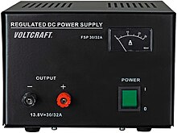

Literature Review
The development of regulated power supplies has been a focal point in electrical engineering, evolving alongside advancements in technology. Early systems relied on rudimentary linear regulation techniques, which, although effective, were limited by low efficiency and significant heat dissipation. With the advent of switching power supplies, efficiency improved dramatically, paving the way for compact and high-performance designs. Modern research highlights the integration of digital control methods and adaptive feedback mechanisms to enhance stability and response times. Studies have also explored the use of renewable energy sources and sustainable materials in power supply designs, aligning with global efforts toward energy conservation and environmental protection.

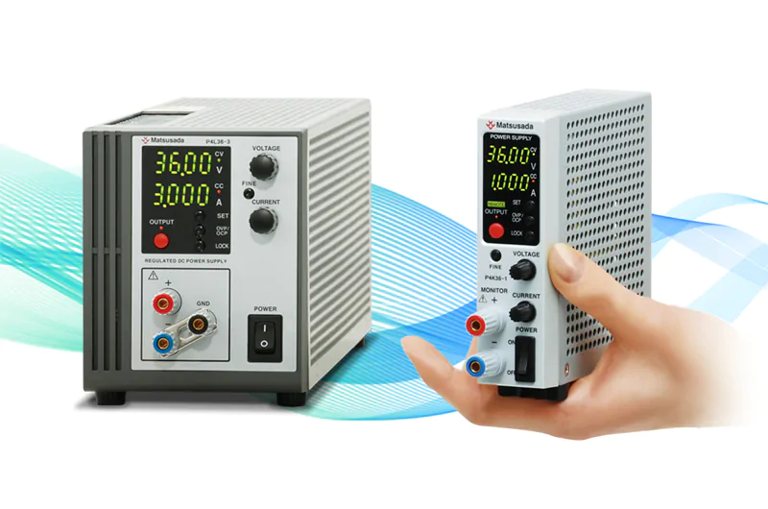
Methodology
Designing a modern regulated power supply involves multiple stages, each critical to the system's overall performance. 1. Transformer Design: The process begins with selecting an appropriate transformer to step down the input voltage to a manageable level. Considerations include power rating, efficiency, and thermal performance.
2. Rectification: The rectifier circuit, typically using diodes, converts alternating current (AC) into pulsating direct current (DC). Full-wave rectification is preferred for its higher efficiency and smoother output.
3. Filtering: Filters, primarily capacitor-based, are employed to reduce voltage ripples in the rectified DC. Advanced designs may use inductors or active filtering techniques for improved performance.
4. Voltage Regulation: The regulator circuit ensures a constant output voltage, even under varying input or load conditions. Linear regulators are simple but less efficient, while switching regulators provide high efficiency and compactness.
Rigorous calculations and simulation models support each stage to validate the design before physical implementation.
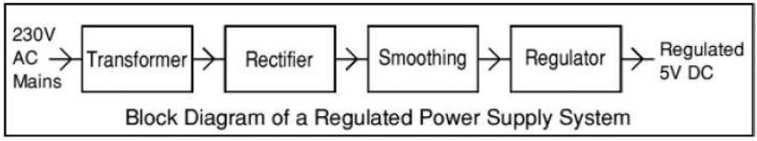
Results (Simulation)
Simulation plays a crucial role in the design validation process, providing insights into the power supply's behavior under different conditions. Key results include:
Rectifier Output: Waveforms showing the transition from AC to pulsating DC, indicating the effectiveness of the rectification process.
Filtered Output: Data highlighting the reduction of ripples, demonstrating the filter’s efficiency in smoothing the rectified signal.
Regulated Output: Graphs comparing the input voltage fluctuations with the stable output voltage, confirming the regulator’s performance.
These simulations not only validate the theoretical design but also identify areas for optimization, ensuring the final product meets all specifications.
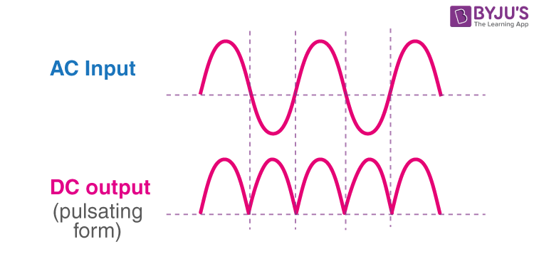
Discussion
The results of the simulation confirm the effectiveness of the designed power supply in maintaining a stable and reliable output. The choice of components, such as high-efficiency diodes and advanced filtering techniques, plays a pivotal role in achieving desired performance metrics. Challenges such as heat generation in linear regulators and potential electromagnetic interference in switching designs are acknowledged, with recommendations for mitigation strategies. These include the use of heat sinks, proper PCB layout techniques, and shielding. This discussion emphasizes the balance between theoretical design and practical considerations, highlighting the importance of component quality and integration in achieving a robust solution.

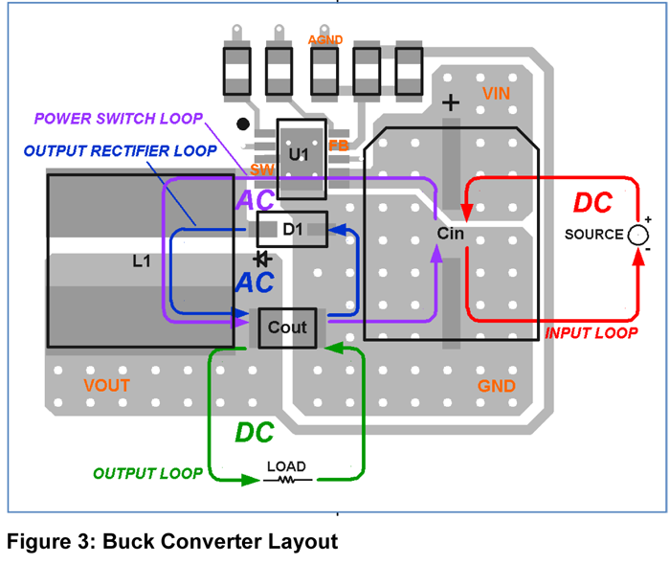

Conclusions
The design and development of a modern regulated power supply require a comprehensive understanding of electrical principles and practical engineering techniques. This report demonstrates the methodology for creating a system capable of delivering stable power under diverse conditions, with applications in various industries. The insights gained from this process highlight areas for future exploration, such as incorporating smart control algorithms for adaptive performance and utilizing environmentally sustainable materials. The knowledge acquired here serves as a foundation for advancing power supply designs to meet the evolving demands of modern technology.
References
1. Sedra, A. S., & Smith, K. C. (2014). Microelectronic Circuits. Oxford University Press.
2. Erickson, R. W., & Maksimovic, D. (2007). Fundamentals of Power Electronics. Springer.
3. Pressman, A. I., Billings, K., & Morey, T. (2009). Switching Power Supply Design. McGraw-Hill.
4. IEEE Journals and Conference Proceedings on Power Electronics and Regulation.
5. Manufacturer Datasheets for Voltage Regulators and Power Supply Components.

